**Testing Report**

Unit testing report: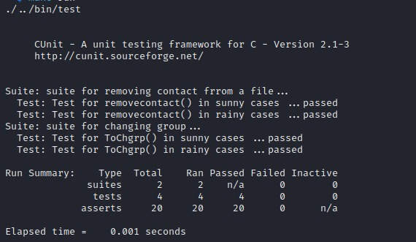

Integration testing report:

Case 1:Anonymous user

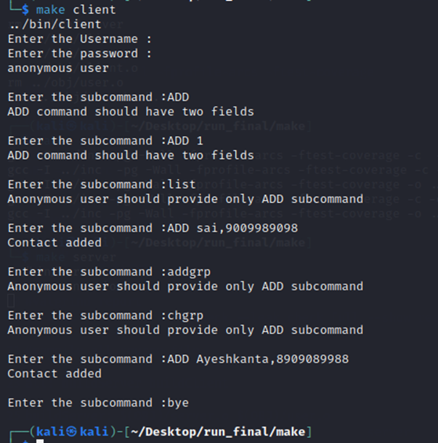

Case 2:Authenticated user

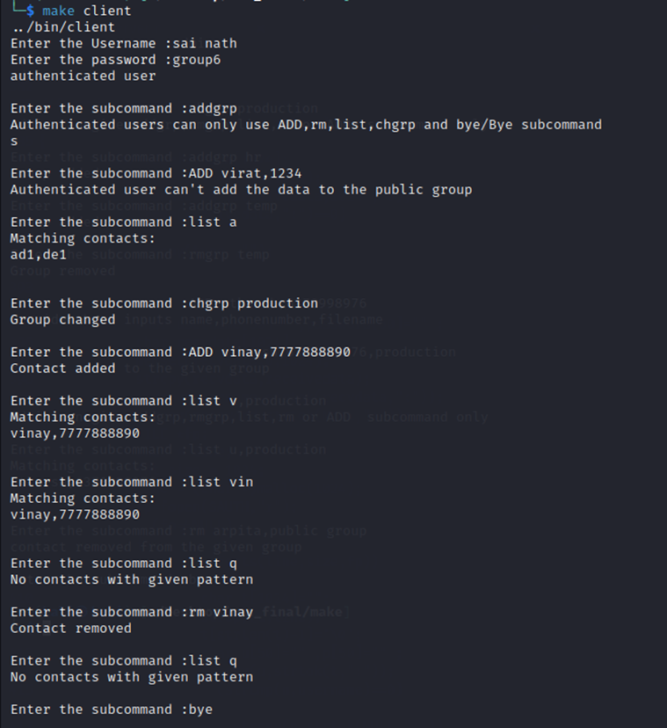

Case 3:Admin authenticated user

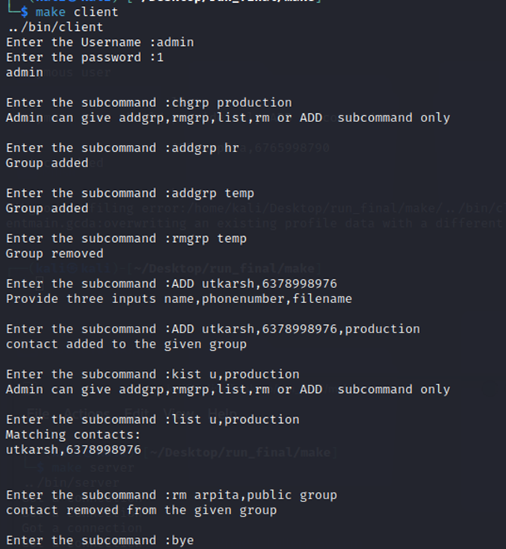

Case 4: Handling multiple clients

